Mage brawl

Cuprins

Character

Model
The character will be presented as a blue wizard hat with two spheres as hands. A wand is present in his right hand, the wand is placed in the right side of the hand, with the player seeing only half – one quarter of the original hand.
The character has:
- 100 health
- 100 mana

Animation

Idle
The hat will sway lightly left to right and both arms (also the wand) swaying gently front to back

Move
The hat sways left to right and the arms will sway front to back.

Attack
The wand tip starts at the back of the character, and maintaining the base in the place, the tip rotates towards the front.
The wand starts in front of the character with an angle of -45 degrees and rotates to an angle of 45 degrees

Control
Movement – WASD
Look – Mouse arrow
Attack – Left click
Change wand – Right click
Interact - E

Camera
A top-down view with the player in the center and with the camera always following the player

Enemies

State machine
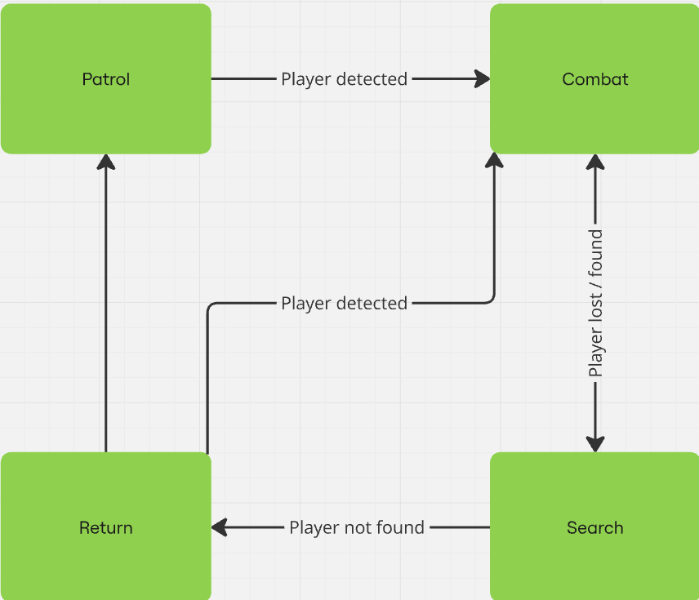

Patrol
In patrol state the NPC will move between 2 – 4 preset points until the player enters the detection zone

Combat
In attack mode the NPC starts casting spells towards the player and has a 10%-30% chance to dodge an attack.
To dodge the NPS will simply move out of the way of the incoming attack, this will not make the NPC invulnerable or safe it, if it is slow.

Search
In search mode the NPC will go toward the last place the player was seen and look around with the detection zone doubled

Return
In return mode the NPC will return to the start of his path and start Patrol mode

Others

Spells

Fireball

Thunder

Ice Spear

Rock

Items

Orbs
An orb is a round item dropped by the enemy, when the player gets near the orb it will start moving toward him and will increase mana/health when it enters in contact with the player.

Mana orb
Player gains 5 – 15 mana.

Health orb
Player gains 5 – 15 health.

Potions
A potion is an item that will give the player mana/health upon use (E), the player can have only one potion at any time.
To pick up / switch the potion the player needs to press E when he is near a dropped potion, if the there is no potion near him then he will consume the potion at hand.

Mana potion
Player gains 40 mana.

Health potion
Player gains 40 health.

Wands

Fire Wand

Electric Wand

Ice Wand

Earth Wand

Interface

